Resume Research

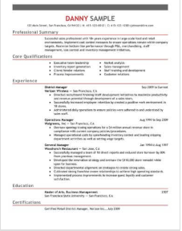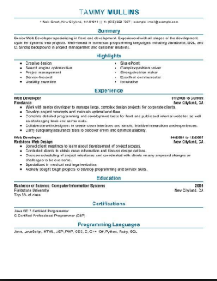

Resume example #2.

Resume example #1.

I decided to base my resume for this project off of the style of resume #1. I like the simple and readable design of this resume style. It has a coherent flow of information and presents the content in a visually pleasing manner. I will change rearrange and exclude some of the sections of this resume example to fit my needs, I will mostly use the design of this resume to create my own.

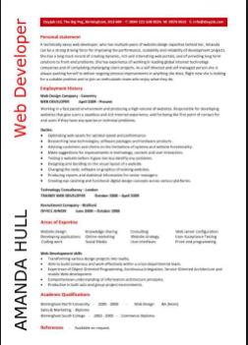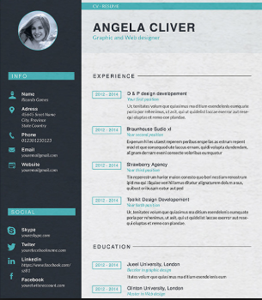

Resume example #4.

Resume example #3.

Resume example #4.